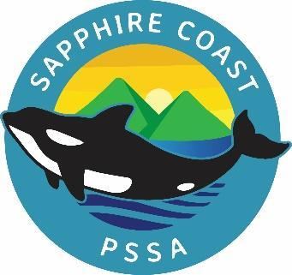
Sapphire Coast District PSSA
Athletics Carnival 2025
Field events will run at the same time as some track events. Please make sure you are aware of when your event will run. The order of events may change during the course of the day at the discretion of the Carnival Organisers.

TRACK EVENTS |  | FIELD EVENTS
Age Race Heats-starts 9am |  | HIGH JUMP- starts 9am
1. 8 yrs Boys 100m |  | 1. 12/13 yrs Girls HIGH JUMP
2. 9 yrs Boys 100m |  | 2. Junior Boys HIGH JUMP
3. 10 yrs Boys 100m |  | 3. 12/13 yrs Boys HIGH JUMP
4. 11 yrs Boys 100m |  | 4. Junior Girls HIGH JUMP
5. 12 yrs Boys 100m |  | 5. 11 years Girls HIGH JUMP
6. 8 yrs Girls 100m |  | 6. 11 years Boys HIGH JUMP
7. 9 yrs Girls 100m |  | LONG JUMP- starts 9am
8. 10 yrs Girls 100m |  | 1. Junior Girls LONG JUMP
9. 11 yrs Girls 100m |  | 2. 11 Years Boys LONG JUMP
10. 12 yrs Girls 100m |  | 3. 11 Years Girls LONG JUMP
Age Race Finals |  | 4. 12/13 yrs Girls LONG JUMP
11. 8 yrs Boys 100m |  | 5. Junior Boys LONG JUMP
12. 8 yrs Girls 100m |  | 6. 12/13 yrs Boys LONG JUMP
13. 9 yrs Boys 100m |  | DISCUS- starts 9am
14. 9 yrs Girls 100m |  | 1. 11 yrs Girls DISCUS
15. 10 yrs Boys 100m |  | 2. Junior Girls DISCUS
16. 10 yrs Girls 100m |  | 3. Junior Boys DISCUS
17. 11 yrs Boys 100m |  | 4. 11 yrs Boys DISCUS
18. 11 yrs Girls 100m |  | 5. 12/13 yrs Boys DISCUS
19. 12 yrs Boys 100m |  | 6. 12/13 yrs Girls DISCUS
20. 12 yrs Girls 100m |  | SHOT PUT- starts 9am
21. 13 yrs Boys 100m |  | 1. 12/13 Boys SHOT PUT
22. 13 yrs Girls 100m |  | 2. 12/13 Girls SHOT PUT
200m Time Finals |  | 3. Junior Girls SHOT PUT
23. Junior Boys 200m |  | 4. 11 Yrs Girls SHOT PUT
24. 11 yrs Boys 200m |  | 5. 11 yrs Boys SHOT PUT
25. 12/13 yrs Boys 200m |  | 6. Junior Boys SHOT PUT
26. Junior Girls 200m
27. 11 yrs Girls 200m
28. 12/13 yrs Girls 200m

At Conclusion of Field Events-800m
29. Junior Boys 800m
30. Junior Girls 800m
31. 11 yrs Boys 800m
32. 11 yrs Girls 800m
33. 12/13 yrs Boys 800m
34. 12/13 yrs Girls 800m

Relays
35. Junior Boys Relay
36. Junior Girls Relay
37. Senior Boys Relay
38. Senior Girls Relay

- Multi class events will be held with like events in the program, depending on number of entries
- 1500m events will be held after the conclusion of the program.

